SONARCLOUD TOKEN:- c097f5d061df0a4f01b0a6fda4Sc9ccc81ecd1aa8

<properties>

<sonar.organization>vasudev-parab</sonar.organization>

<sonar.host.url>https://sonarcloud.io</sonar.host.url>

</properties>

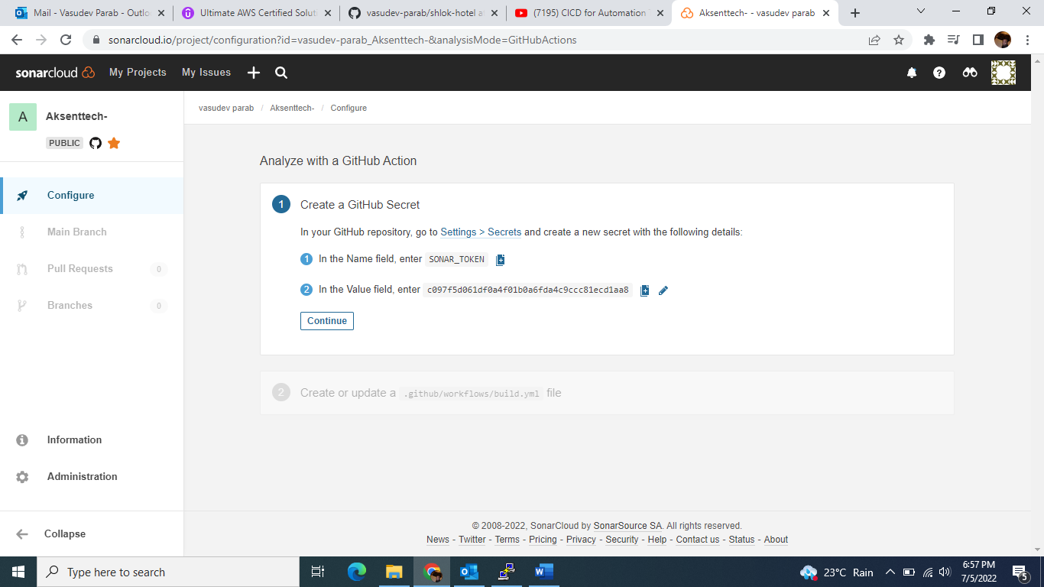

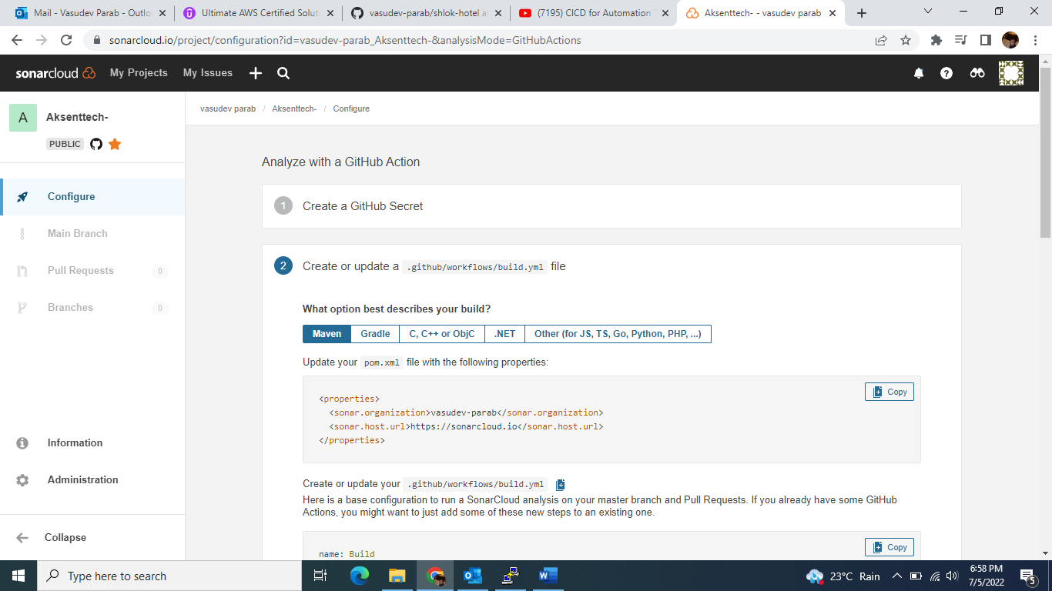

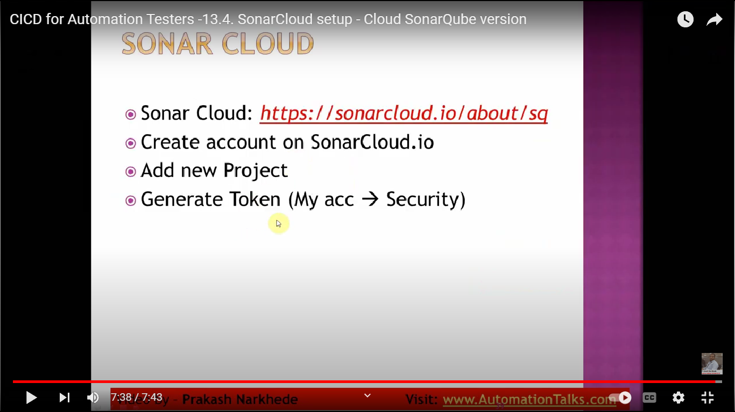

First go to the manage Jenkins->and search in Available”sonarqube scanner”->then click on “install without restart”

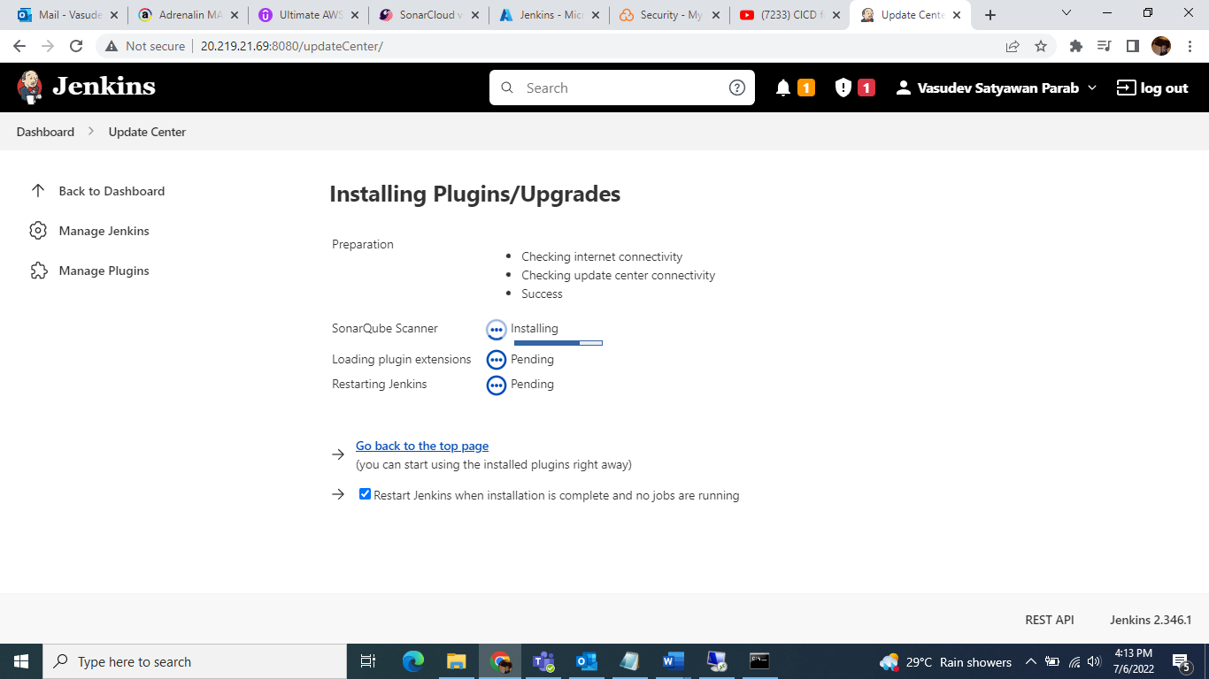

Ones install sonarqube scanner go to the-> configuration system->see sonarqube servers option

